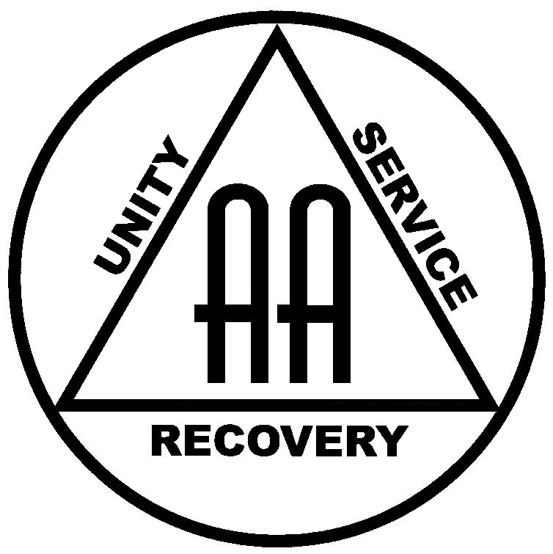 | Alcoholics Anonymous  Helpline: 0800 9177 650  www.alcoholics-anonymous.org.uk

Introduction
The Alcoholics Anonymous (AA) public information function seeks to improve communication, understanding, and cooperation between AA and professionals who work with or encounter alcoholics, to maximise assistance to those wishing to recover from alcoholism.

Where it all started
AA was founded in 1935 by a New York stockbroker and an Ohio surgeon, who were both classed as ‘hopeless’ alcoholics. In the early days of AA, most members had been at the very late stages of alcoholism, their drinking having taken them to hospitals, sanatoriums, and prisons.
However, as more and more people began to hear about AA, many found that they did not have to let their condition inflict so much damage before seeking help. They discovered that they could recover in AA before their health had been gravely impaired and while they still had their jobs and families.

Worldwide recovery
Today there are over 115,000 local AA groups in 170 countries around the world. In Great Britain, there are over 4,500 groups composed of people of all ages and from all walks of life. Members help each other to achieve and maintain sobriety by using the AA programme, also known as the ‘Twelve Steps’.
Groups hold regular meetings, which take one of two forms: ‘closed’ and ‘open’ meetings. Closed meetings are only for those who believe they have a drinking problem and generally involve group discussion of the recovery programme, with members sharing their experience of how they have recovered. By contrast, there are ‘open’ meetings, at which invited AA speakers describe their drinking and its consequences, how they discovered AA, and how its programme has helped them. Members may bring family and friends to these, and any professionals or other individuals in the community who are interested in AA are welcome to attend. AA meetings also take place in prisons, hospitals, and other institutions, at the request or invitation or with the permission of the appropriate authorities.

Communication and cooperation
Although not allied with any other group or organisation, AA is always ready to cooperate with professionals who encounter people with an alcohol problem. In particular, AA volunteers are able to offer talks to or discussions with groups of professionals on the programme of recovery and AA more generally. These talks will typically explain AA through the prism of an individual member’s experience, may include an audiovisual element, and can clarify how AA can be used as a resource for professionals assisting problem drinkers.
As AA’s tradition states that it is self-supporting through the voluntary contributions of its members and does not accept any outside funding, there are no fees for such services. AA members engaged in public information work offer their time freely in an effort to help the alcoholic into recovery and to ensure their own continued sobriety. There are also no dues or fees for membership, although a voluntary collection is taken at meetings to pay the running expenses of meetings and shared costs of the fellowship as a whole.

National Helpline: 0800 9177 650
Anyone who believes that they may have a problem with alcohol and wishes to stop drinking may join AA. Contact can be made by simply calling the helpline, which is typically answered by a member local to the caller. There is an email helpline: help@aamail.org, and there is also a ‘chat now’ facility available at https://www.alcoholics-anonymous.org.uk/About-AA/Newcomers/Get-help-now. These channels are staffed by AA members, in other words alcoholics who have found a solution in AA.

